MODULE 5 ASSIGNMENT

Advance topics in a function

- Write a function add to add two numbers and call the function in another file.
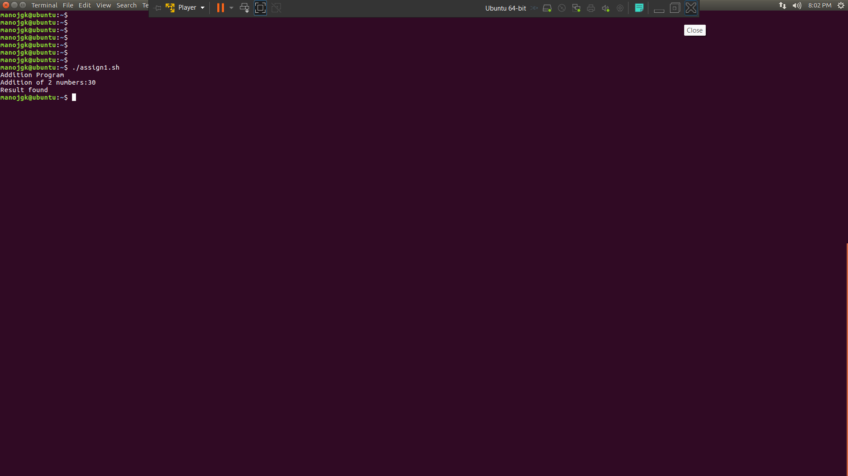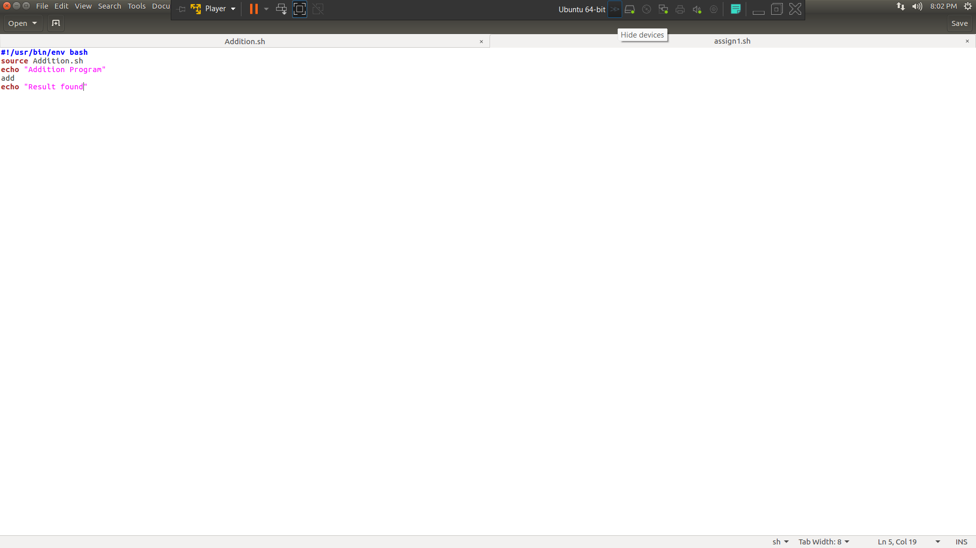
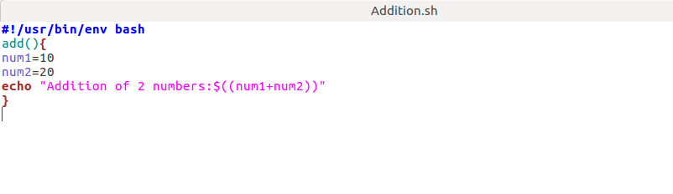
Recursive function

2)Write a program where the recursive function calculates the sum of N numbers
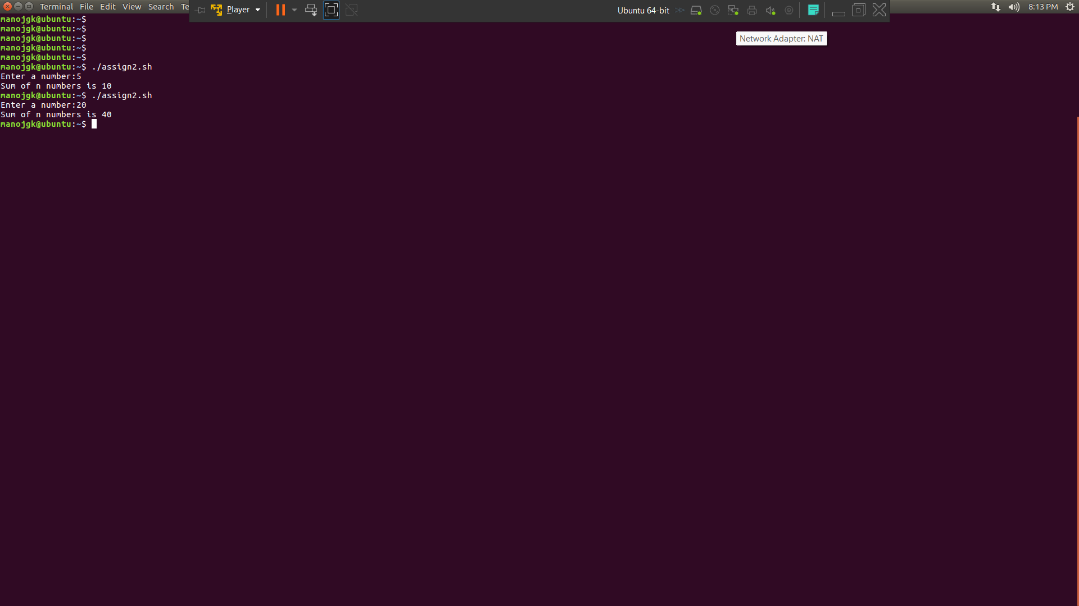
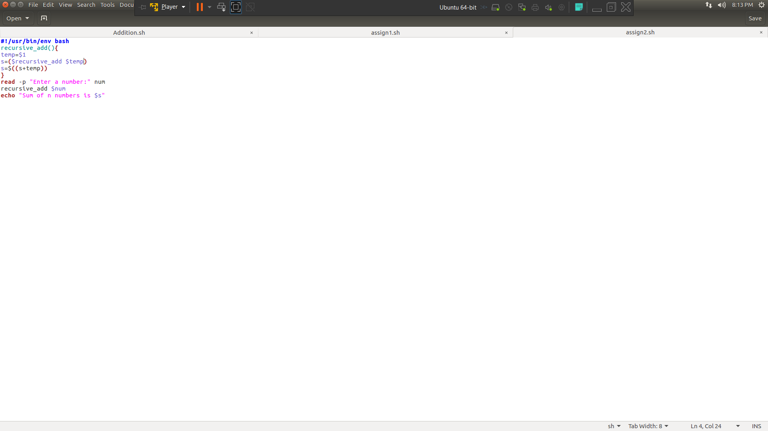
Basics of Redirection (error handling)

3) Create a text file with some content like your name, address.
4) Redirect the content to a new file.

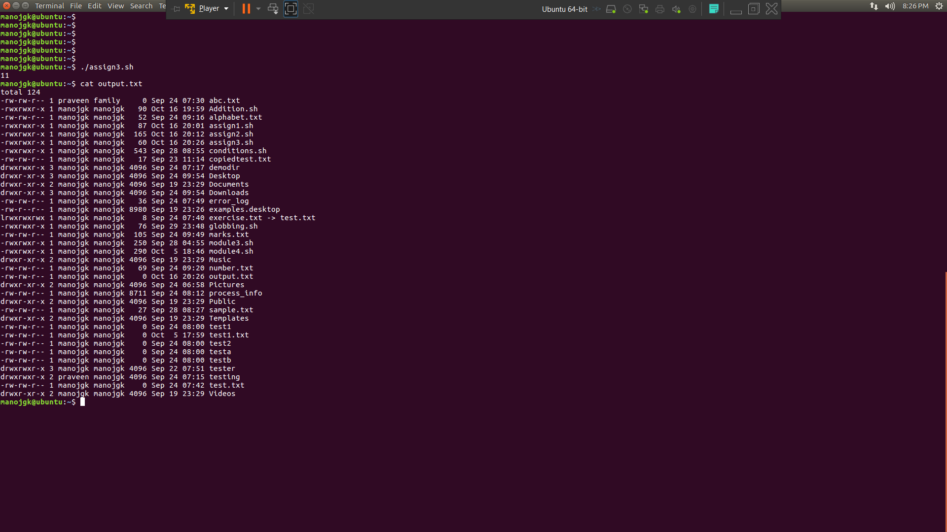
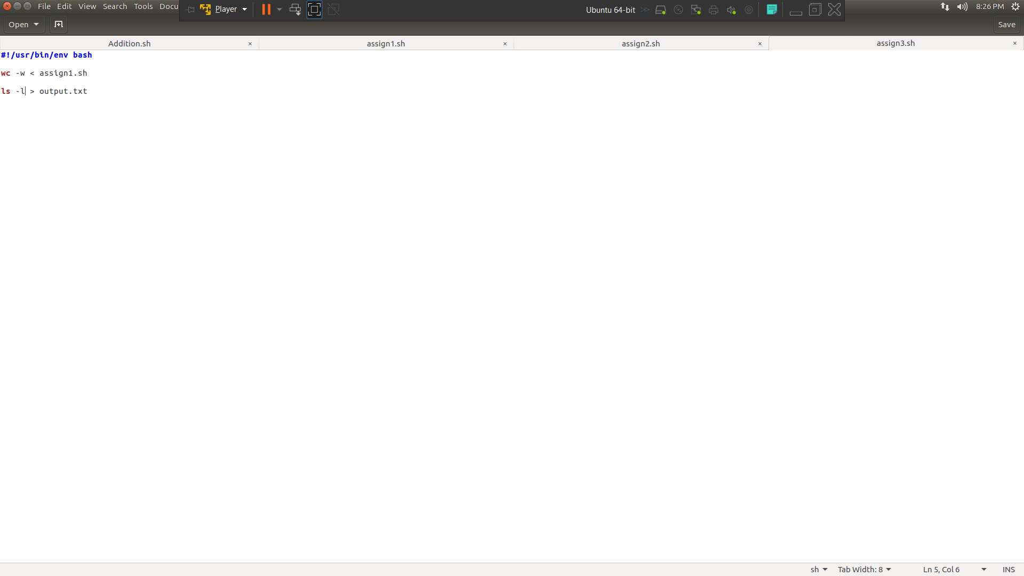
More on Redirection

1) Create X_file.txt file with some content.
2) Redirect the content of both out_file.txt and X_file.txt to a new file

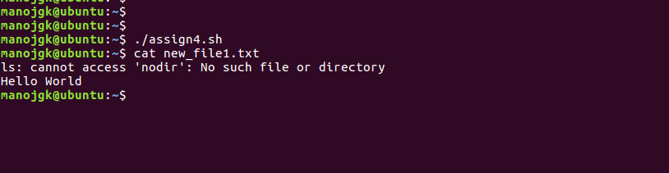
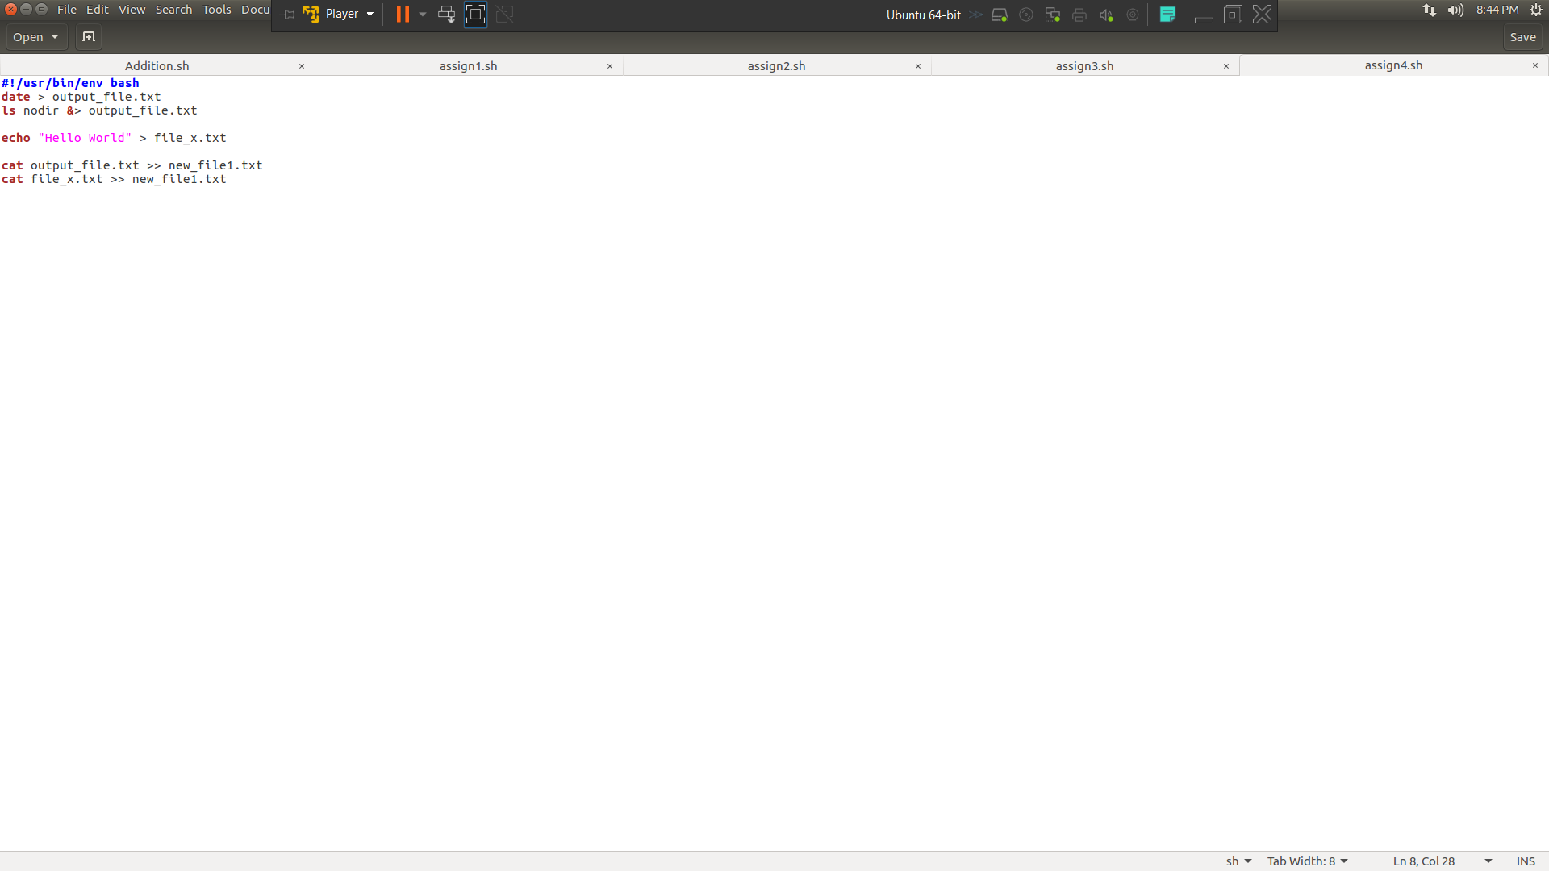
Here document and Here string

1) Convert a string to uppercase using:
a) Here document
b) Here string

Hint: tr a-z A-Z

